Tadworth Primary School
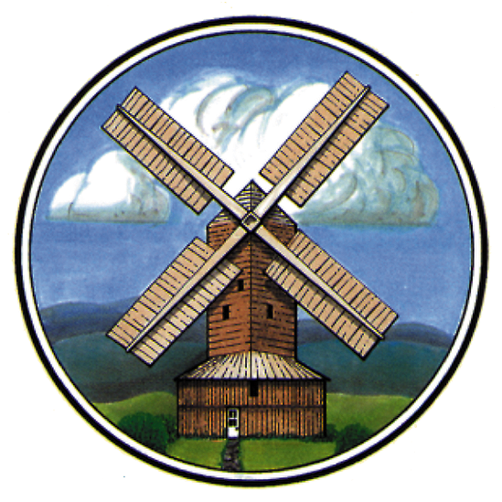

School Uniform and Appearance Policy

Spring 2022

School uniform and appearance policy

We believe that school uniform plays a valuable role in contributing to the ethos of our school. The aim of our school uniform is to present a smart appearance which promotes a sense of belonging and pride in our school.

Boys and Girls:
Blue polo shirt or blue button up shirt. From Year 3 onwards only button up shirts are allowed
Smart black school shoes (no trainers) which offer suitable support for playtime and running around the playground
Tadworth reversible fleece/water resistant coats are also available if parents wish to purchase them *

Girls:
Grey pinafore dress or skirt (knee length) or grey school regulation trousers
Bottle green school sweatshirt or cardigan with Tadworth badge *
Black or grey tights

Girls (Summer Uniform - optional):
Green/white check school summer dress
White socks

Boys:
Grey long or short trousers
Bottle green school sweatshirt with Tadworth badge *
Grey socks

PE Kits for boys and girls:
Green school PE polo shirt with Tadworth logo *
White shorts
School tracksuit *
Trainers—These are worn for outdoor PE so should be comfortable and durable
Green Tadworth PE Bag †

Hairstyling:
Hairstyling: Shoulder length/long hair must be tied back using a plain dark green hairband or summer dress material scrunchie, or bobble (no big bows)
Hair should be no shorter than grade 3 and no ‘shaved-in’ designs

Earrings:
No jewellery is to be worn in school except for basic watches which are worn at the owner’s own risk
No child is to wear earrings of any sort in school. If they do, they will not be able to participate in any outside or sport-related activity for health and safety reasons

Coats, Bags, Water bottles:
Road safety organisations recommend that children wear bright coats to travel to and from school to ensure maximum visibility. In order to maintain a smart appearance please avoid coats with overpowering logos.
Children from Yr R to Yr 2 must have a Tadworth Book Bag †. Water bottles are also available †.

Other:
Tattoos, transfers and nail polish must not be worn in school

Items marked * are only available from Stevensons. (Epsom Store or online https://www.stevensons.co.uk/school-finder/tadworth-primary-school-tadworth)
Items marked † are only available from school.
All items should be clearly named please including vests, socks and shoes.
If you are in any doubt over the school’s expectations with regards to any aspect of our Uniform and Appearance Policy, please speak to the school before making any decisions.

Policy agreed
Policy to be reviewed | As deemed necessary

